Weitzman ECHO Complex Integrated Pediatrics Registration
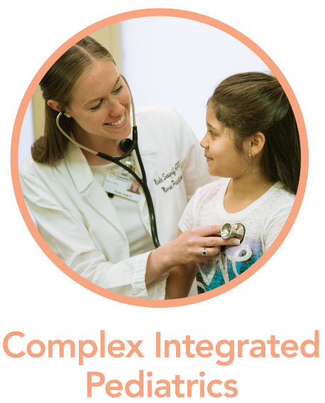
All medical and behavioral health providers seeing pediatric and/or adolescent patients in a primary care setting (including school based health centers) are welcome. To learn more about this program, please click here. If you are ready to sign up, please fill out the form below to register.
Sessions will be held on the 2nd and 4th Wednesdays of each month from 12:00PM to 1:00PM ET after a special kickoff session on Tuesday, September 15th at the same time.
Participants who register are asked to join as many sessions as possible over the one year curriculum and be willing to present at least one case for recommendations.. If you would just like to observe one session to determine if this program is the right fit for you, please email us. Please read and adhere to the Terms of Participation. Your registration below confirms your acceptance of these Terms.
Register below. After you complete the registration form, we will follow up with onboarding information so that you can join our live sessions. If you have any questions, please reach out to Lindsey Lehet, Program Specialist, at LehetL@chc1.com.
The Complex Integrated Pediatrics program is supported in part by the Health Resources and Services Administration (HRSA) of the U.S. Department of Health and Human Services (HHS) as part of two awards totaling $101,429 and $333,362 with 0 percent financed with non-governmental sources. The contents are those of the author(s) and do not necessarily represent the official views of, nor an endorsement, by HRSA, HHS, or the U.S. Government. For more information, please visit HRSA.gov.​

