QI ESSENTIALS TOOLKIT:
Cause and Effect Diagram
A common challenge for improvement teams is determining what changes they can test to improve a process. A cause and effect diagram is an organizational tool that helps teams explore and display the many causes contributing to a certain effect or outcome. It graphically displays the relationship of the causes to the effect and to each other, helping teams identify areas for improvement.

The cause and effect diagram is also known as an Ishikawa diagram, for its creator, or a fishbone diagram, for its resemblance to the bones of a fish. Teams typically list and group causes under the categories of Materials, Methods, Equipment, Environment, and People.

IHI’s QI Essentials Toolkit includes the tools and templates you need to launch and manage a successful improvement project. Each of the 10 tools in the toolkit includes a short
description, instructions, an example, and a blank template.
•

•
•
Cause and Effect Diagram
Driver Diagram Failure Modes and Effects Analysis (FMEA)
•
•
•
•
Flowchart Histogram Pareto Diagram
PDSA Worksheet
•
•

•
Project Planning Form
Run Chart & Control Chart
Scatter Diagram

Copyright © 2017 Institute for Healthcare Improvement. All rights reserved. Individuals may photocopy these materials for educational, not-for-profit uses, provided that the contents are not altered in any way and that proper attribution is given to IHI as the source of the content. These materials may not be reproduced for commercial, for-profit use in any form or by any means, or republished under any circumstances, without the written permission of the Institute for Healthcare Improvement.

Institute for Healthcare Improvement · ihi.org

Instructions
- Write the effect you wish to influence in a box on the right-hand side of the page.

- Draw a horizontal line across the page to the left, starting at the box you just drew.

- Decide on five or six categories of causes for the effect. The standard categories in a classic cause and effect diagram are Materials, Methods, Equipment, Environment, and People.

- Draw diagonal lines above and below the horizontal line to create “fishbones,” and label each line at the end with one of the categories you have chosen. Draw a box around each label.

- For each category, generate a list of the causes that contribute to the effect. List the causes by drawing “branch bones.” As necessary, draw additional branch bones from the causes to show sub-causes.
  - Tip: Develop the causes by asking “Why?” until you have reached a useful level of detail
— that is, when the cause is specific enough to be able to test a change and measure its effects.

Example: Cause and Effect Diagram

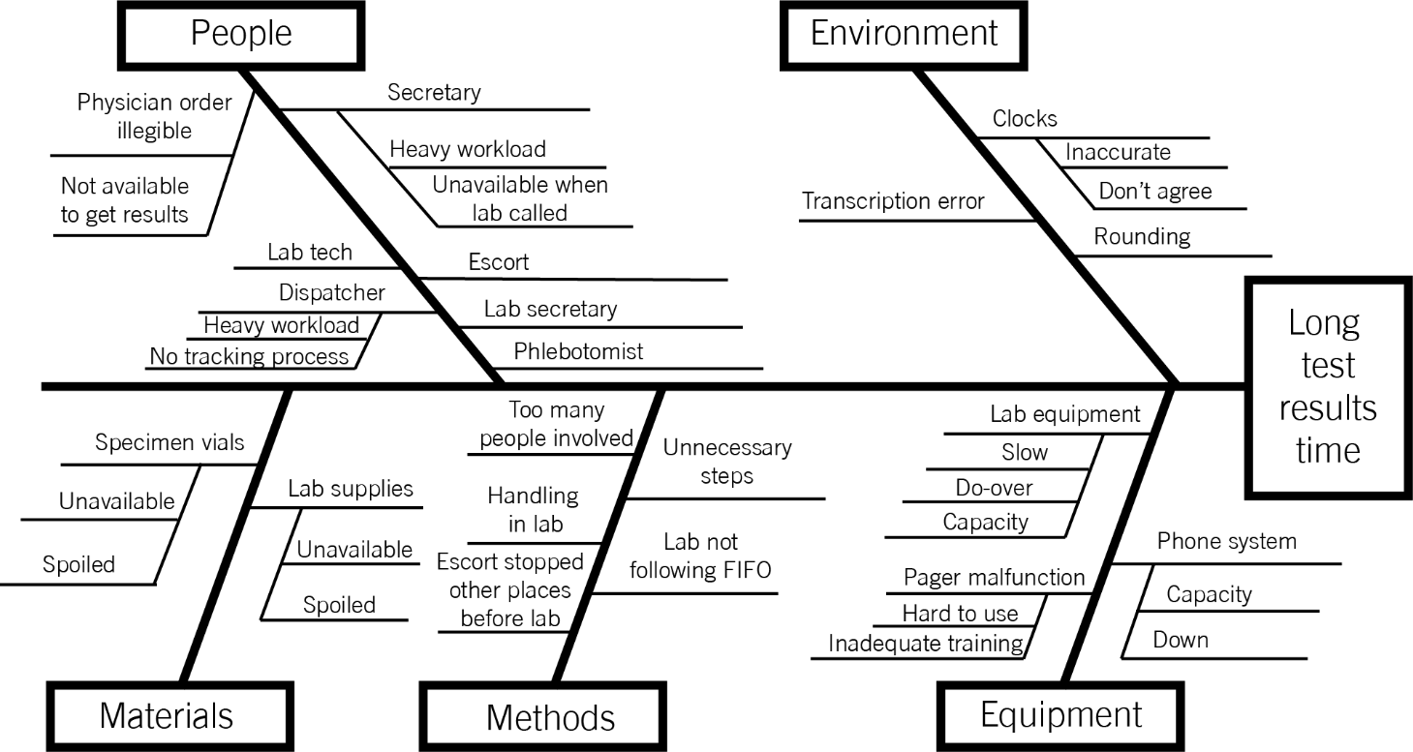

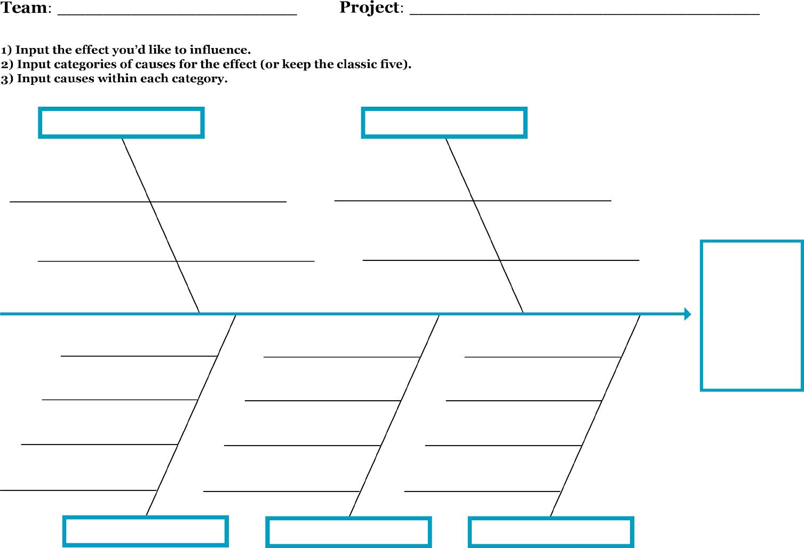
QI Essentials Toolkit: Cause and Effect Diagram

Template: Cause and Effect Diagram

People Environment

Input causes here.

Input causes here.

Materials Methods Equipment

Institute for Healthcare Improvement ∙ ihi.org

Look at:
Access to Care: Needs and preferences, supply and demand, 3rd next available appointment, A

Patient experience: quantitative: access, communication, coordination, whole person care (self-management, comprehensive); qualitative
Obtains feedback from vulnerable population

Quality improvement: Sets goal and aims to improve
Clinical quality: immunization MMR
Patient experience
Care Coordination
Monitoring access

Meeting needs of vulnerable population: Do we want to look at where patients live that need outreach and intervention in case there are alternative visit sites that might work; i.e. schools, churches?

