PCMH Kids Family Survey Summary for PCHC
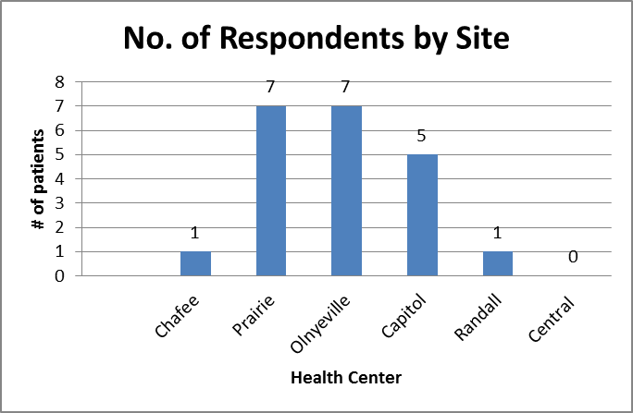
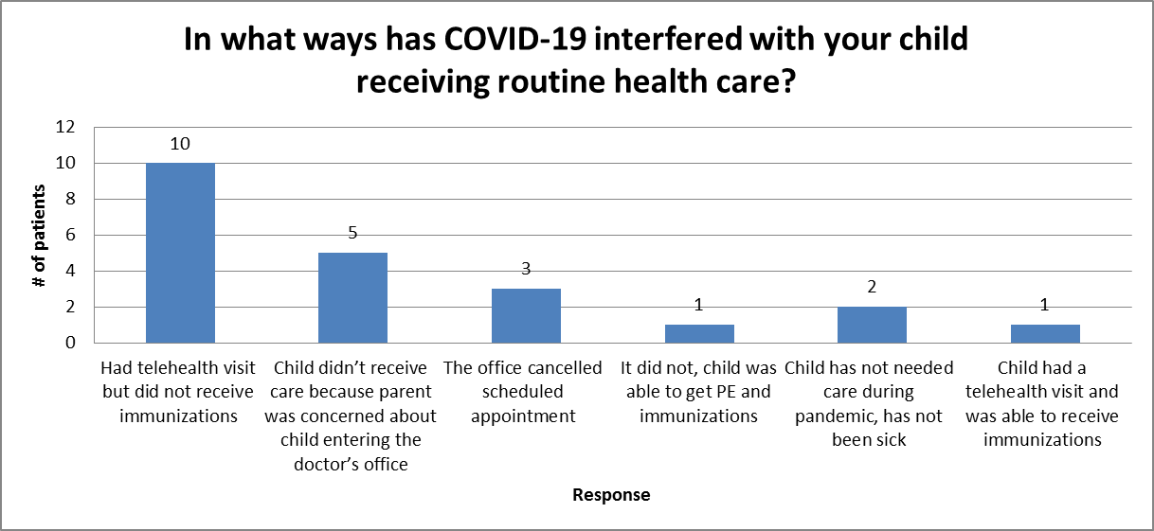
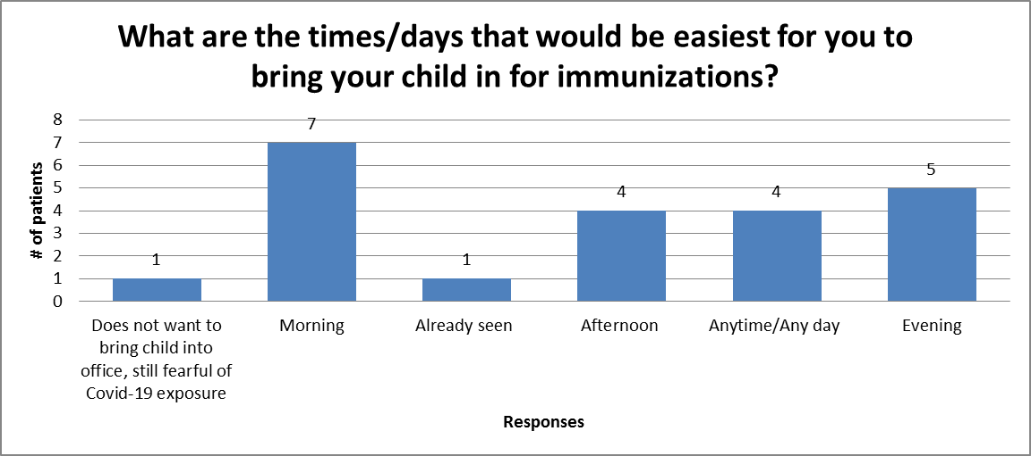
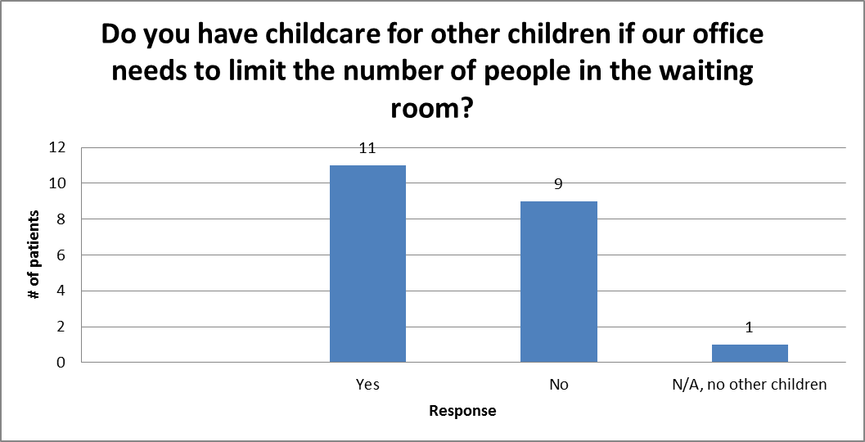
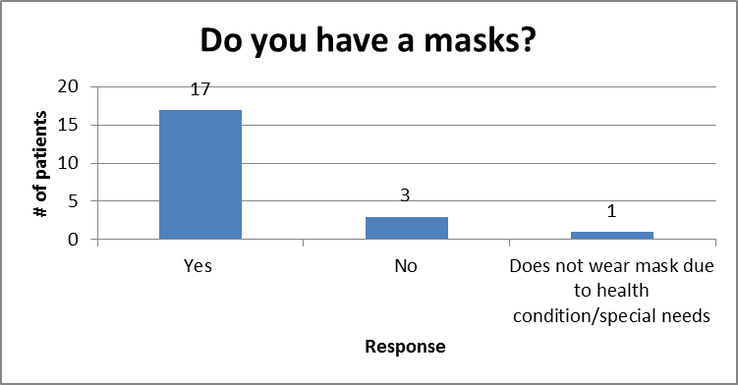

What resources/assistance do you have available to help you with coming into our office so your child can get “caught up” on immunizations?
None
Case manager
Transportation
MTM
Spouse
Friend
Phone
Lyft
Health Center
Does not need any, child all set

Do you have other suggestions that might make it easier for you to bring your child in for a well-child visit and immunization visit?
“Bring both children at the same time”
“Doing a physical on the phone rather than coming into the clinic”
“Providing a ride to their appointment”

