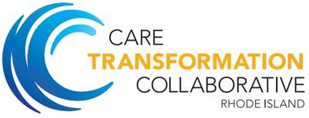

Clinical Practice Champion Quarterly Learning Session
May 11, 2018
7:30am-9:30am

The Rhode Island Shriners Imperial Room
1 Rhodes Place
Cranston, RI 02905

- Welcome and CTC Program Updates Pano Yeracaris 7:30-7:40am
- Integrated approach to diabetes care Marty Kerzer, DO, 7:40-8:10am
Kristin David, PsyD;

- Case review and programmatic update Karyn Horowitz, MD 8:10-8:45am
- An overview and lessons learned to date from the CTC IBH project Nelly Burdette, PsyD. 8:45- 9:25am
- Wrap Up Pano Yeracaris 9:25-9:30am

