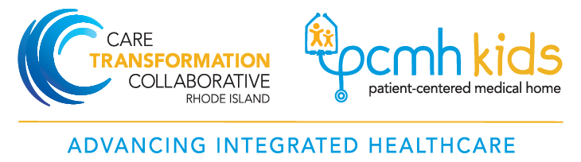

Rhode Island Department of Health  Leadership Team | Care Transformation Collaborative of Rhode Island (CTC – RI)  Management and Practice Facilitation Team
Deborah Garneau, MA  Maternal & Child Health Director  Office: 401-222-5929  Deborah.Garneau@health.ri.gov | Susanne Campbell, RN, MS, PCMH CCE  Senior Project Director  Office: 401 519-3925  Cell: 401 477-0011  SCampbell@ctc-ri.org
Jim Beasley, MPA  Program Manager  Cell: 401-486-4536  Jim.Beasley@health.ri.gov | Carolyn Karner, MBA  Data Manager  Office: 978-852-2250  CKarner@ctc-ri.org
Monika Drogosz, MPH  Program Evaluator  Office: 401-222-1274  Monika.Drogosz@health.ri.gov | Pano Yeracaris, MD, MPH  Chief Clinical Strategist  Office: 617-953-5501  pyeracaris@ctc-ri.org
Jennifer Levy, MD, MPH  Consultant Medical Director  Jennifer.Levy@health.ri.gov | Suzanne Herzberg, PhD, MS, OTR/L  Practice Facilitator  Cell: 401-263-6023  Suzanne_Herzberg@brown.edu
Jordan Catherine White, MD, MPH  Consultant Medical Director  Jordan.White.ctr@health.ri.gov | Vicki Crowningshield, MPH, PCMH CCE  Practice Facilitator  Office: 401-528-3292  VCrowningshield@healthcentricadvisors.org
Jody Vieira, LICSW
Practice Facilitator
Cell: 401-862-4045
jvieira2020@outlook.com

Jade Arruda, BS
Project Coordinator
Cell: 774-271-2221
JArruda@ctc-ri.org

