How to Access High Risk Reports from Health Plans and Communicate with Health Plans

Each health plan has agreed to deliver to practices on a quarterly (at least) basis a list of high risk patients whom they wish to be referred for care management services. Health plans use different predicative modeling methodologies to produce these lists based on cost, utilization, and/or chronic conditions. Health plans also have different methods of delivering these reports to practices, as outlined below; however, all lists will be labeled as “High Risk Report, Quarter, Year.”
CTC Management asks practices to designate three contacts at the practice to be the recipients of the high risk lists from health plans that send via secure email. These designees should be confirmed at least quarterly. The designated contacts can be identified and updated by contacting Candice Brown for practices in Adult CTC program (CBrown@ctc-ri.org ) and Carolyn Karner for practices in the PCMH Kids program (CKarner@ctc-ri.org).

Practices should review the patients that are referred from the health plans at least quarterly with the clinical team and determine which patients are “high impact.” CTC has identified a common definition of “high risk” patients that is used by all CTC practices.
Health Plans have identified a “point person” that practices can use when assistance is needed to access high risk lists and a “point person” for clinical needs and for health plan high risk issues. This document included health plan contact information.

Contents
Blue Cross & Blue Shield of Rhode Island 2
Neighborhood Health Plan 3
Tufts Health Plan 5
UnitedHealthcare Commercial and Medicaid……………………………………………………………………………………………….7

Blue Cross & Blue Shield of Rhode Island

Blue Cross & Blue Shield of Rhode Island (BCBSRI) provides practices with monthly patient panels of all active, attributed BCBSRI members, including those identified as high risk. These panels provide clinical and cost information to assist NCMs/CCs in their management of members. Patient panels are distributed to practices or key contacts through a secure method.
BCBSRI identifies high risk members through the use of The Johns Hopkins ACG System. The ACG system is a statistically valid, diagnosis-based, case-mix methodology that describes and predicts future healthcare utilization and costs. This system is based on the premise that the level of resources necessary for delivering appropriate healthcare to a population is correlated with the illness burden. BCBSRI assigns a risk category (Red or Orange) to further assist practices in identifying members with the highest need for case management intervention and support. Criteria are as follows:

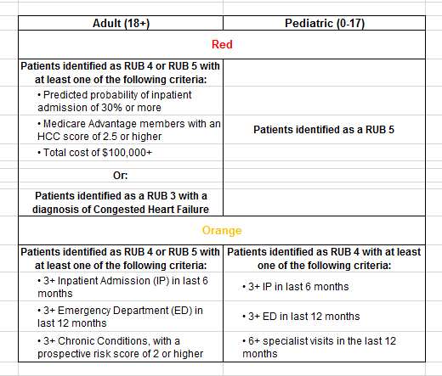
Nurse Care Managers (NCMs) and Care Coordinators (CCs) are responsible for case management (CM) of identified high risk members. NCMs/CCs will document engagement of BCBSRI high risk members on patient panels. BCBSRI defines engagement as members who have agreed to participate in case management with the NCM/CC and have an active care plan in place. BCBSRI has an engagement target of 45% of identified high risk members. NCMs/CCs need to document all CM services provided in the previous calendar quarter by no later than the 20th calendar day, or closest business day, of the first month of each calendar quarter (January 20th, April 20th, July 20th, and October 20th
Contact Information:
Please contact your assigned Practice Facilitator for PCMH program-related questions. Additional points of contact include:
- General program questions: PCMH@bcbsri.org
Referral to BCBSRI Registered Dieticians and Behavioral Health Case Managers: (401) 459-CARE (2273)

Neighborhood Health Plan
NHP will not deliver high risk patient lists to practices with less than 200 members.

Practices must log on to the NHPRI Provider Report Portal to access the high risk list. Access to the portal, training of the site and setup at the site requires configuration by NHP.
Updated high risk lists will be posted on the 22nd of each month.

  - CTC sites with the exception of those sites discussed previously receive the efficiency suite and the high cost report from Neighborhood.
  - The reports for CTC all are available in excel format. This allows for filtering and manipulation of data.
  - The high cost report in particular is more comprehensive than the data elements identified for the CTC high risk report. There are more data elements in the report.
  - The high cost report contains pharmacy, behavioral health and medical expenses in addition to ER and inpatient utilization.

*CTC practices could utilize this report to identify patients for different levels of care management. See below as to the report labels.

Member Name | Admi ts | Day s | ALO S | ER  Visits | Unique NDC  Categori es | Total Rx Clai ms | Medical Paid | BH  Paid | RX  Paid | Total Paid

For example: A patient with high medical cost, no inpatient utilization, high ER utilization, no BH claims and pharmacy costs under a $100. This patient could be flagged to receive care management touch.
For questions or concerns on the NHP high risk lists, and/or to remove a patient from the high risk list contact Yvonne Heredia at YHeredia@nhpri.org or 401-459-6186 (direct)

NHP high risk list
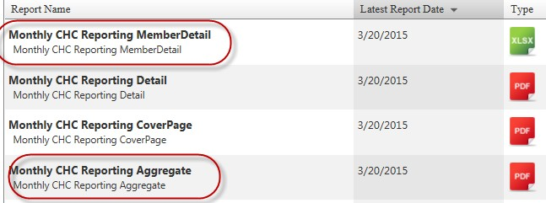
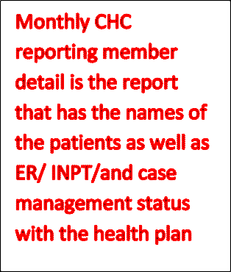
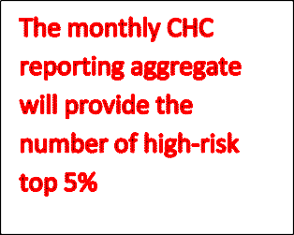
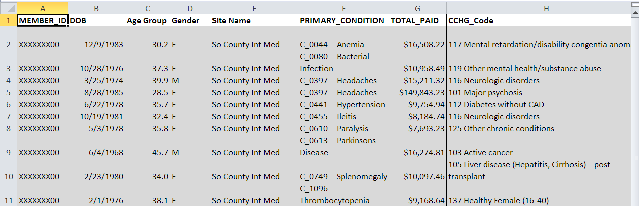

How to access the report on the Provider Portal
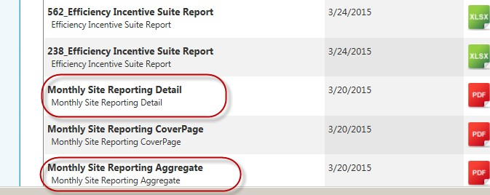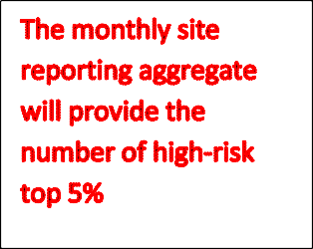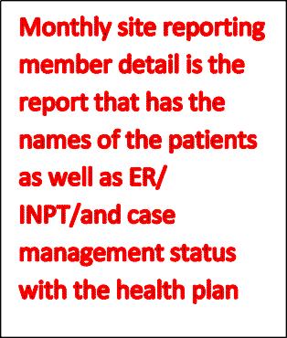
Non- Community Health Centers

Tufts Health Plan
If you do not have any high risk patients, you will be sent a blank report shell.

Tufts Health Plan sends the high risk list at the end of each quarter (January, April, July, and October) via secure email to the designated contacts at each practice site.

The first time that a secure email is sent, click on “View Message” and the secure email portal will open. The user will be prompted to create a password and will be able to check the inbox of the newly created account for secure emails with the reports.

Once an account has been created, the user will only need to click on “View Message” and login with their account credentials to access the secure email inbox.

For questions or concerns on the Tufts high risk lists, contact Brianna Goddard Brianna_Goddard@tufts-health.com or 617-972-9400 x52160 or Michele Wolfsberg RN MPH Michele_Wolfsberg@tufts-health.com (617)972-9400 x59747.

Screen shot of Tufts Health Plan’s High Risk List

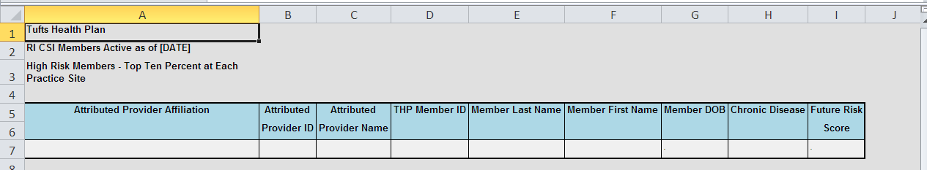
UnitedHealthcare Commercial and Medicaid

Both the UHC Commercial and Medicaid high risk reports can be accessed through uhcprovider.com
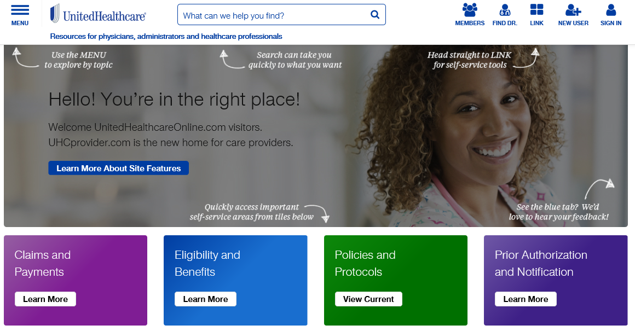
COMMERCIAL REPORTS:

- Commercial high risk information is accessed through the Integrated Patient Care Applications (iPCA) app on the Link dashboard.

- To begin, click on the Link icon in the top right corner. Follow the on screen prompts to sign in.

- Go to the Clinical Dashboard and select the iPCA app.

- Within iPCA you will see several report options.

- The Patient Registry Search Library provides an avenue for providers to accurately identify their high-risk population based on multiple factors of medical utilization.
  - Updated Monthly
  - Includes most accurate and up-to-date risk predictive model
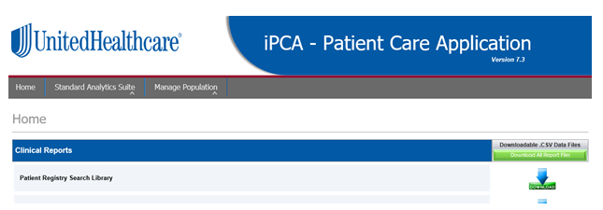
- The results of the search can be downloaded for use by the care manager
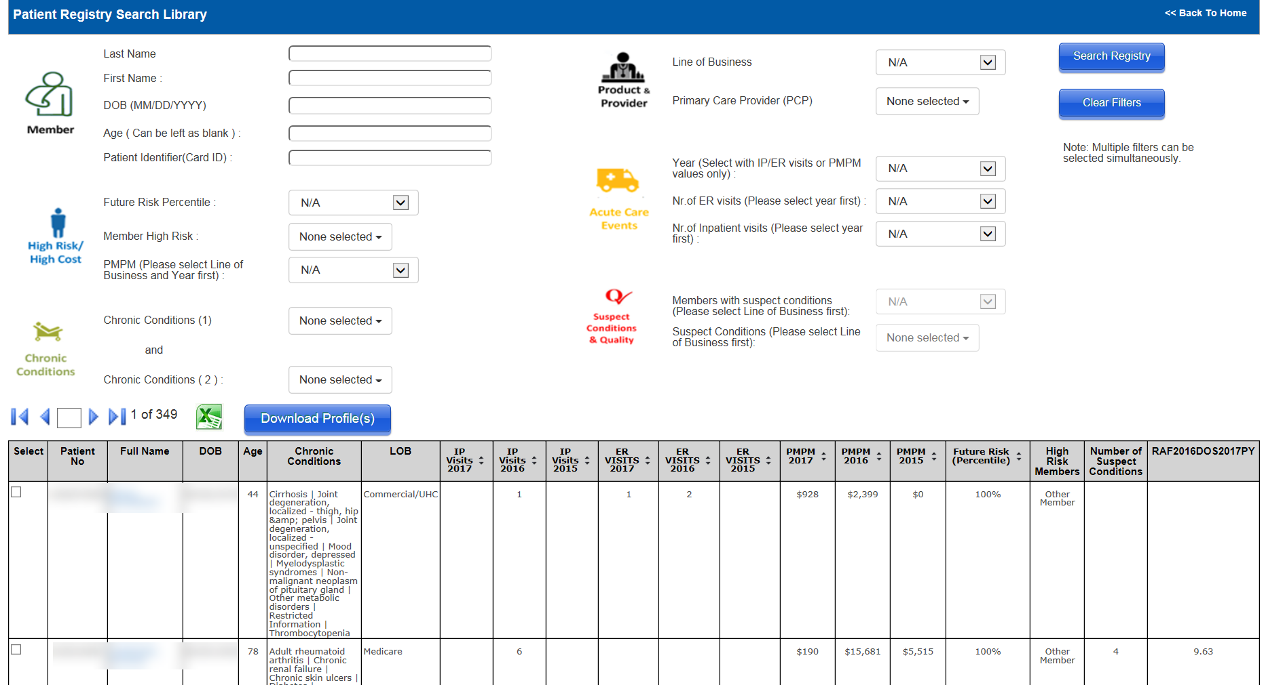

If you need any assistance navigating through the iPCA application or would like more information on how to effectively use the Patient Registry Search Library, please contact your UHC Clinical Transformation Consultant.

MEDICAID REPORTS:
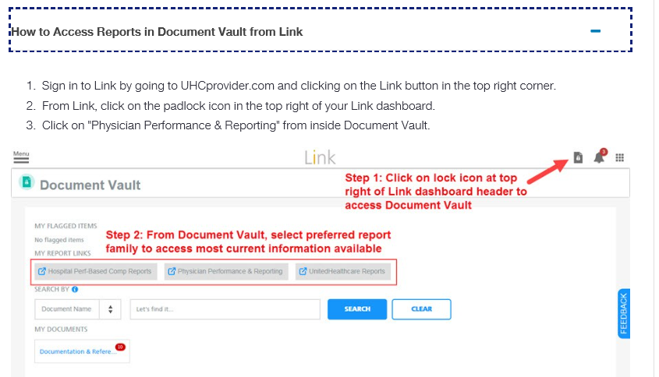
- You will be prompted to “Connect” to the account you wish to view

Note: The PIN Registration screen may appear if your account is not yet linked to your corporate tax I.D. The Program Identification Number (PIN) is a practice-specific number, and will only need to be entered once. If you need your PIN number, please see your practice administrator, or contact your UHC consultant.

- The reports will open in a separate tab or window, depending on your browser settings.

- Clicking on “View” for a report will launch option to Open or Save.
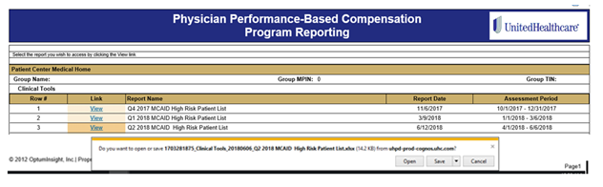
If you would like to learn more about these reports, please contact your UHC Clinical Transformation Consultant.

UHC Clinical Transformation Consultant: Sandy Curtis at sandra.curtis@uhc.com.

