The 10 best blood pressure apps-

Link: https://www.medicalnewstoday.com/articles/320095.php
Published Thursday 16 November 2017
By Hannah Nichols
Fact checked by Jasmin Collier
If you have been diagnosed with high blood pressure, it can be a constant worry to try and bring down your numbers. We have chosen the best apps to track, monitor, and help you to keep blood pressure within a healthy range.

Blood pressure apps are designed to help you track, monitor, and manage your blood pressure.
High blood pressure affects around 77.9 million, or 1 in 3, adults in the United States, and 18.5 percent of them are unaware that they have the condition. It is normal for blood pressure to rise and fall throughout the day, but if it remains high for an extended period, it can cause heart problems and other health-related issues.
High blood pressure can put an excessive amount of pressure on artery walls, which can damage the body's blood vessels and organs. Uncontrolled high blood pressure can lead to heart attack or stroke, aneurysm, heart failure, weakened blood vessels in the kidneys, vision loss, and reduced thinking ability.
Making lifestyle changes can go a long way toward helping to control your blood pressure. Your doctor may recommend regular exercise, following a healthful diet, maintaining a healthy weight, managing stress, and quitting smoking. Sometimes, though, changing your lifestyle is not enough and your doctor may recommend medication.
Only half of all people with high blood pressure have it under control. But there are many apps that either specialize in blood pressure or help you to make lifestyle changes to lower your high blood pressure.
Here are Medical News Today's choices of the 10 best blood pressure apps to help keep your blood pressure in check.

Blood Pressure Companion
iPhone: Free
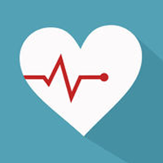
Blood Pressure Companion tracks blood pressure, heart rate, and weight. The app has a clean interface that can be used to visually monitor your blood pressure through a log, chart, and histogram.
The app allows straightforward tracking of systolic and diastolic blood pressure in a chart. The mean arterial pressure of each reading can also be calculated. Blood Pressure Companion allows you to create reminders for measuring your blood pressure and even doctors appointments.
When your readings are abnormal, you can quickly and efficiently determine what may be causing your blood pressure to skyrocket and lower it accordingly. Using the app, your blood pressure measurements can also be shared with your doctor.

Heart Habit
iPhone: Free
The Heart Habit app is a smart, easy, and creative way to track and manage your risk of high blood pressure, heart attack, and stroke. If you have already had a heart attack or stroke, Heart Habit is the perfect companion to manage your future risk.
The app is developed in collaboration with physicians, dieticians, and pharmacists from Stanford University, the University of California, San Francisco, the University of California, Davis, and Kaiser Permanente.
Through educational content, recommendations, and personal insight and trends across activities and lifestyle choices, the Heart Habit app can pave the way for you to achieve perfect blood pressure and a healthy heart.

Pacer
Android: Free
iPhone: Free
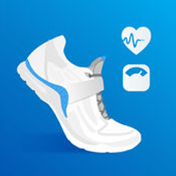
Pacer is a pedometer and step tracker that feels like having a fitness coach and walking buddy all in one place. Their guided workouts and personalized fitness plans aim to help you achieve your fitness goals.
Physical activity can help to lower your blood pressure. Engaging in regular exercise such as walking for 30 minutes on most days of the week has been shown to reduce blood pressure by 4–9 millimeters of mercury.
Whether your phone is your hand, pocket, or purse, the Pacer app will track your steps all day long and record distance traveled, activity duration, and calories burned. It is also possible to create walking groups with your family and friends to stay motivated.

My Diet Coach
Android: Free
iPhone: Free
My Diet Coach is the fun and easy way to lose weight. The app helps you to discover what keeps you motivated, how to stay on track and avoid food cravings, and how to make small and healthful lifestyle changes.
Being obese puts you at a much higher risk of developing high blood pressure. As your weight increases, so does your blood pressure. If you are overweight and have high blood pressure, one of the best things that you can do is decrease your body weight. Even losing 10 pounds can help to lower your blood pressure.
Set your weight loss goal with My Diet Coach and track your progress. The app has a pictorial weight tracker so that you can visually see your weight decreasing. My Diet Coach provides motivating tips and quotes and rewards you when you are successful.

Sleep Cycle
Android: Free
iPhone: Free
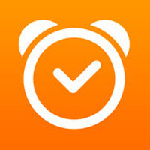
Sleep Cycle is a smart alarm clock that analyzes your sleep patterns and wakes you up in your lightest phase of sleep. Waking up in the lightest sleep phase will help you to wake up feeling well rested and relaxed.
Adults are recommended to have between 7 and 9 hours of sleep per day. It is thought that sleeping for under the recommended hours is associated with an increase in blood pressure.
The deepest sleep stage functions to restore our physical and mental health. Disruption of deep sleep may have an adverse effect on blood pressure and contribute to high blood pressure. Using Sleep Cycle can help you to set aside those all-important 7 hours of sleep and wake you up without disrupting your deepest sleep phase.

Smoke Free
Android: Free
iPhone: Free
Smoke Free is based on more than 20 evidence-based techniques to help you quit smoking. The app shows you how much money you have saved by not smoking, how many cigarettes you have not smoked, and the time you have been smoke-free. The app details how much of your life you have regained and shows how your health is improving.
You can identify trends in your cravings by using a map to see where they occur, notes to view patterns, and a graph to see them going down. The app also provides tips on how to deal with them.
While smoking is not a direct cause of high blood pressure, smoking increases your risk of having a heart attack or stroke. Smoking and high blood pressure both narrow the arteries. Therefore, if you smoke and have high blood pressure, your arteries may narrow at a faster rate and significantly raise your risk for heart disease.

Calm
Android: Free
iPhone: Free
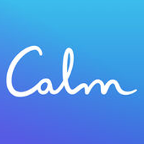
Calm is a meditation and mindfulness app with the goal of reducing anxiety, stress, and sleep problems through their guided meditation programs. The programs are perfect for both those who have never meditated before and those at an intermediate or advanced level.
The direct link between stress and blood pressure is still being studied, but what we do know is that stressful situations can lead to temporary elevations in blood pressure. Repeated spikes in blood pressure can build up and may eventually contribute to high blood pressure.
Using Calm can help you to manage your stress levels and lower your chances of experiencing repeated short-term blood pressure increases. Meditations come in a variety of durations so that you can find the perfect one to fit your schedule.

Breathing Zone
iPhone: $3.99
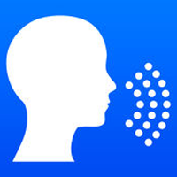
Breathing Zone provides a mindful breathing exercise to slow down your breathing rate, calm you down, and make you feel relaxed. Breathing Zone aims to "change your life one breath at a time."
Breathing exercises that feature in yoga and meditation have shownsome success in helping to treat high blood pressure, and research has demonstrated that taking six deep breaths over a period of 30 seconds reduced systolic blood pressure when compared with sitting quietly.
Breathing Zone is an easy-to-use app that requires you to do nothing more strenuous than breathing in and out. There are no complicated settings or breathing patterns to master.

Qardio
Android: Free
iPhone: Free
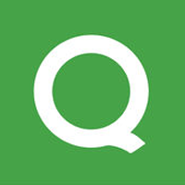
Qardio is the ultimate heart health tracker. Its makers boast that the app can track more metrics than any other health app available right now.
Qardio can track your blood pressure, weight, and electrocardiogram. You can also keep tabs on heart rate, irregular heartbeat, body mass index (BMI), weight, body composition, calories, skin temperature, and steps.
The app is easy to set up and connects to any Qardio device. Both your heart health and weight management progress are viewable through charts, statistics, and trends. It is simple to instantly share your data with friends, family, and doctor.

HealthWatch 360
Android: Free
iPhone: Free
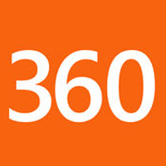
Among other factors, maintaining a healthy weight, eating a balanced diet, reducing salt intake, and drinking alcohol in moderation can help to prevent high blood pressure. HealthWatch 360 is a scientifically designed nutrition app that can help you to achieve those dietary goals.
Begin by selecting a health and wellness goal, such as blood pressure. The app's algorithm will then generate a personalized nutritional plan and provide you with daily reports on your nutrition status.
The HealthWatch 360 app enables you to monitor more than 30 nutrients in a database of more than 500,000 foods and supplements. With the app, you can track your intake of calories while ensuring that you get all the nutrients you need to function at your best.

