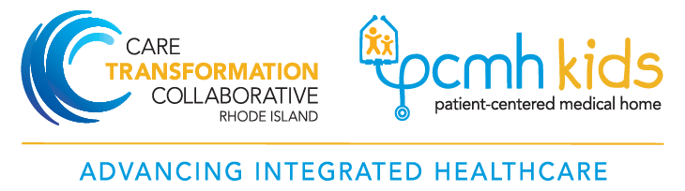

Rhode Island Department of Health  Leadership Team | Care Transformation Collaborative of Rhode Island (CTC – RI)  Management and Practice Facilitation Team
Ailis Clyne, MD, MPH  Medical Director  Office:  ailis.clyne@health.ri.gov | Susanne Campbell, RN, MS, PCMH CCE  Senior Project Director  Office: 401 519-3925  Cell: 401 477-0011  SCampbell@ctc-ri.org
Jaime Comella, MPH  Program Manager  Office:  Jaime.Comella@health.ri.gov | Candice Brown, BS  Program Coordinator  Office: 401-519-3919  CBrown@ctc-ri.org
Jim Beasley, MPA  Program Manager  Office: 401-222-1597  Jim.Beasley@health.ri.gov | Jayne Daylor, RN, MS  Practice Facilitator  Cell: 401-529-7678  SDaylor@cox.net
Monika Drogosz, MPH  Public Health Epidemiologist  Office: 401-222-7720  Monika.Drogosz@health.ri.gov | Suzanne Herzberg, PhD, MS, OTR/L  Practice Facilitator  Cell: 401-263-6023  suzanne_herzberg@brown.edu
Vicki Crowningshield, MPH, PCMH CCE
Practice Facilitator
Office: 401-528-3292
vcrowningshield@healthcentricadvisors.org

