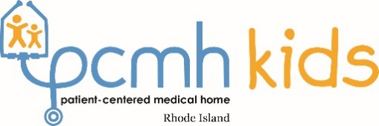
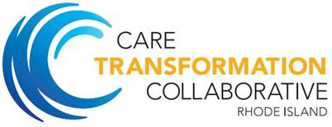

Quarterly Breakfast of Champions
May 10, 2019, 7:30am-9:00am
The Rhode Island Shriners Imperial Room, 1 Rhodes Place, Cranston, RI 02905

1. Welcome and Agenda Review | Pano Yeracaris, MD, MPH | 7:30-
CTC-RI Clinician Well-Being Survey Results 2019 | Chief Clinical Strategist | 7:45am
https://bit.ly/2LvWxdB | CTC-RI
2. Combating Clinician Burnout with Community-Building  Evolution of Clinician Experience  https://bit.ly/2VXbaKQ | Nicolas S. Nguyen, MD  Senior Medical Director Clinician  Recruitment, Development, and | 7:45-8:35am
 | Experience
 | Beth Israel Deaconess HealthCare Clinical Instructor Harvard Medical School
3. Teamwork 101: Core Skills for Effective Collaboration | Phillip G. Clark, PhD | 8:35-
Quick overview for high-functioning teams in clinical setting | Professor and Director | 9:00am
Co-author of Healthcare Teamwork: Interprofessional Practice and Education | Program in Gerontology and  RI Geriatric Education Center
 | University of Rhode Island

Evaluation/Feedback

Your 3-Question SurveyMonkey feedback by Friday, May 17 is important to us.

Please scan the below QR Code or use this link: https://bit.ly/2JnMENW

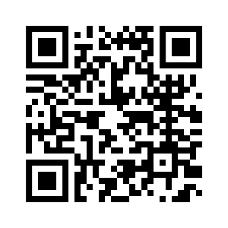
Save the Dates!
Quarterly Breakfast of Champions, Friday, September 13, 2019, 7:30-9:00am
Annual Conference, Thursday, October 24, 2019, 7:30-3:30pm

