CTC-RI has streamlined the process your practice can use to update your Provider and Care Managers files. On a quarterly basis, you will receive a link that you can use to provide updated information. Following this new process replaces the previous process where you needed to update an excel spread sheet with multiple tabs.

Please Note: The updating of Provider file information is critical because the accurate Provider information drives the health plan attribution numbers required for your Practice to receive Incentive and Infrastructure Payments

We need you to complete the instructions below by March 10, 2019 in order for your practice to receive proper payment from the health plans.

Instructions to Update Provider Form:
Step 1: Click on the Form link here
Step 2: Start to type your Practice/Site Name: you will be provided with an auto suggestion for your Practice Name
Step 3: Select your Practice Name and click Next
You will be redirected to a form that has been prefilled with the current Provider data
In the Provider Information section

- For Existing Providers
  - You only need to make changes if there is new or missing Contact Information, and to provide information on Open/Closed status and 3rd Next Available appointment
  - You can provide updates to all fields except "Practice Role & NPI Number", NPI has been pre-populated based on our current Practice records and it is not a field that would require a change.
  - If the Provider has a role change, indicate this in the text area comment box and CTC-RI will update the record for subsequent reporting cycles.
  - Section on: Provider Open or Closed to New Patients: this field requires updating if blank or incorrect - please select "Open" or "Closed" by using the drop down box feature
  - Section on: Provider's 3rd Next Available Appointment for Existing Patients: this field requires updating if blank or incorrect - please add the appropriate 3rd next available date, or enter "n/a"

- To Add New Providers
  - Click the "Add another response" link located at the bottom of the page
  - Enter the Provider's First Name, Last Name, NPI number, Work Phone, Work Email, and other Phone (if applicable), and select "Provider" and relative options for Practice Role

- To Remove Providers
  - DO NOT CLICK the "Remove" link at the top of the page, if applicable
  - Change the Employment Status to "Former"
  - Add an "End Date" for the Provider

Click "Submit" and you are done!
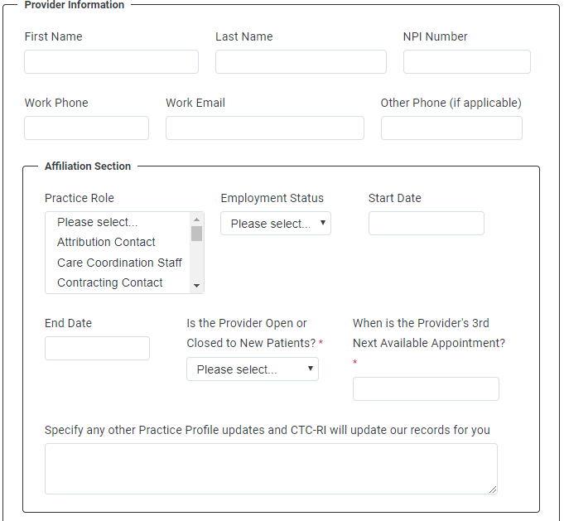

Instructions to Update Care Coordinator Form:
Step 1: Click on the Form link here
Step 2: Start to type your Practice/Site Name: you will be provided with an auto suggestion for your Practice Name
Step 3: Select your Practice Name and click Next
You will be redirected to a form that has been prefilled with the current Provider data
In the Nurse Care Manager / Care Coordinator Information Section
- For Existing NCMs and CCs
  - You only need to make changes if there is new or missing Contact Information for the NCM or CC, and to provide the NCM/CC FTE information
  - Simply click in any field and make changes as you deem appropriate
  - NCM/CC FTE % (Full Time Employment Percentage) - this field requires updating if blank or incorrect
    - The FTE % can be entered as a whole number, i.e. 100, or as a decimal, i.e. 1.0

- For New NCMs or CMs
  - Click the "Add another response" link at the bottom of the page
  - Enter the NCM/CC's First Name, Last Name, Work Phone, Work Email, and other Phone (if applicable)
  - Select "Nurse Care Manager" or "Care Coordination Staff" in the Practice Role drop down list

- To Remove NCM/CC
  - DO NOT CLICK the "Remove" link located at the top of the page, if applicable
  - Change the Employment Status to "Former"
  - Add an "End Date" for the NCM/CC

Click "Submit" and you are done!

